Broughton Moor Healthy Helpers - Marketing Plan
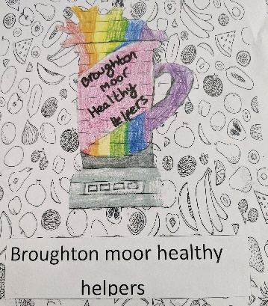

Before selling starts (weeks 1-5) | Target Customers  Our target customers will be other pupils in School, parents and members of our local community in Broughton Moor. Basically, anyone who would appreciate a healthy, home-made refreshment!  We have reading sessions held with all parents after school on Wednesdays so decided this would be a good opportunity to sell smoothies and give out the ones parents and children have pre-ordered. | Our Key Message  We wanted to communicate our message that smoothies are a really good choice instead of fizzy drinks with sugar. We have already learnt a lot about the benefits of different fruit and why reaching our 5-a-day target is so important and so wanted others to know this too. We also wanted customers to know our smoothies are lovingly handmade by the Healthy Helpers – a true artisan product like nothing else in the shops!  They are also very easy to make, so we kept our recipes simple and have done a ‘market test’ to find out our customers’ favourite fruit to include. | The Media/Tools we will use  We are planning our advert which will be shared on social media, Class Dojo and our website which will last around 1 minute and hopefully grab our customers’ interest. Our creative team are also making posters to be placed around school and outside so passers-by can see them.  Of course, word of mouth is also really important and effective (especially in a small school like ours!)
During selling (weeks 5-8) | Securing Orders  We will make pre-order forms so that a certain number of smoothie orders are secured each week of selling and will help us monitor how much fruit we need.  We are also going to offer customers the chance to ‘try before they buy’ so they can see if they like the smoothie before purchasing…which we know they will!  Our offer of 1 smoothie for £1.50 or 2 for £2.50 offers great value and so far, lots of customers have ordered more than one each week meaning our deal is working. | Repeat Customers  We have decided to change our smoothie recipe each week to keep customers’ interested in our product and avoid ‘smoothie boredom!’  Our three flavours are; Coronation Special, Totally Tropical and Sunshine Smoothie – each using different ingredients so there’s a flavour for everyone.  On our first week, we are also making crown sleeves for our cups and selling them for 25p each as a special extra. Hopefully, this will build excitement and get our selling off to a great start. | Our Approach  Our Sales team are practising their sales technique and we have decided we want to be; friendly, approachable and informative.  We want to make a profit, but our main aim is encouraging people to make more smoothies of their own and so will encourage them to try tasters and offer feedback so that we know how we can come back better and stronger each week. We have already decided that we will be asking customers what they thought of their smoothies as much as possible.
Ongoing/after selling (weeks 1-8) | Delivering a Great Experience  We are planning a ‘taste-testing’ session where we will be trying each one of our smoothie flavours before we start selling them. We want to make sure the recipes are as tasty as possible and so we can have lots of confidence in our product.  We are also borrowing Orian’s smoothie bike for one of our selling sessions and it will be in school the whole week for other children to try out. We hope it will bring something a bit different to our selling stall and build excitement around making smoothies – proving it can be really fun and promoting our business. | Overall Impact  Every label on our smoothie cups will list our ingredients which is really important for safety reasons but we also decided we wanted to keep our recipes as simple as possible, with no more than 4 ingredients so that people can remember them and make them at home.  In case they forget, we are also planning to make recipe cards to hand out after selling sessions to make sure that smoothies will continue to be made after the competition ends. By providing extras like this, we hope our customers will recognise the good we are doing and want to support us during the competition. | The HH Legacy  We really enjoyed thinking of our name and creating our logo.  We think that the ‘Healthy Helpers’ is perfect as our aim is to help other people become healthier and make better choices. Our logo needed to be really colourful and eye catching…like fruit is! We think we have already made a really recognisable and memorable brand and this will hopefully mean our legacy continues on after Bright Stars ends in Broughton Moor.

