What is really special about what we are doing? What makes our PRODUCT (or service) stand out? Is it a service, is it helping PEOPLE, what difference does it make?
It’s our first ever Langwathby talent show so it’s very special. It also means that children who have a talent that isn’t normally part of school can show it off and show everyone how good it is.

What PRICE is it? Or if there isn’t a price, what VALUE does it have to local people?
Tickets will be £4 each

Do we want a LOGO (picture) or something that tells people “visually” what we are doing? Square, round….?? Draw some ideas here:
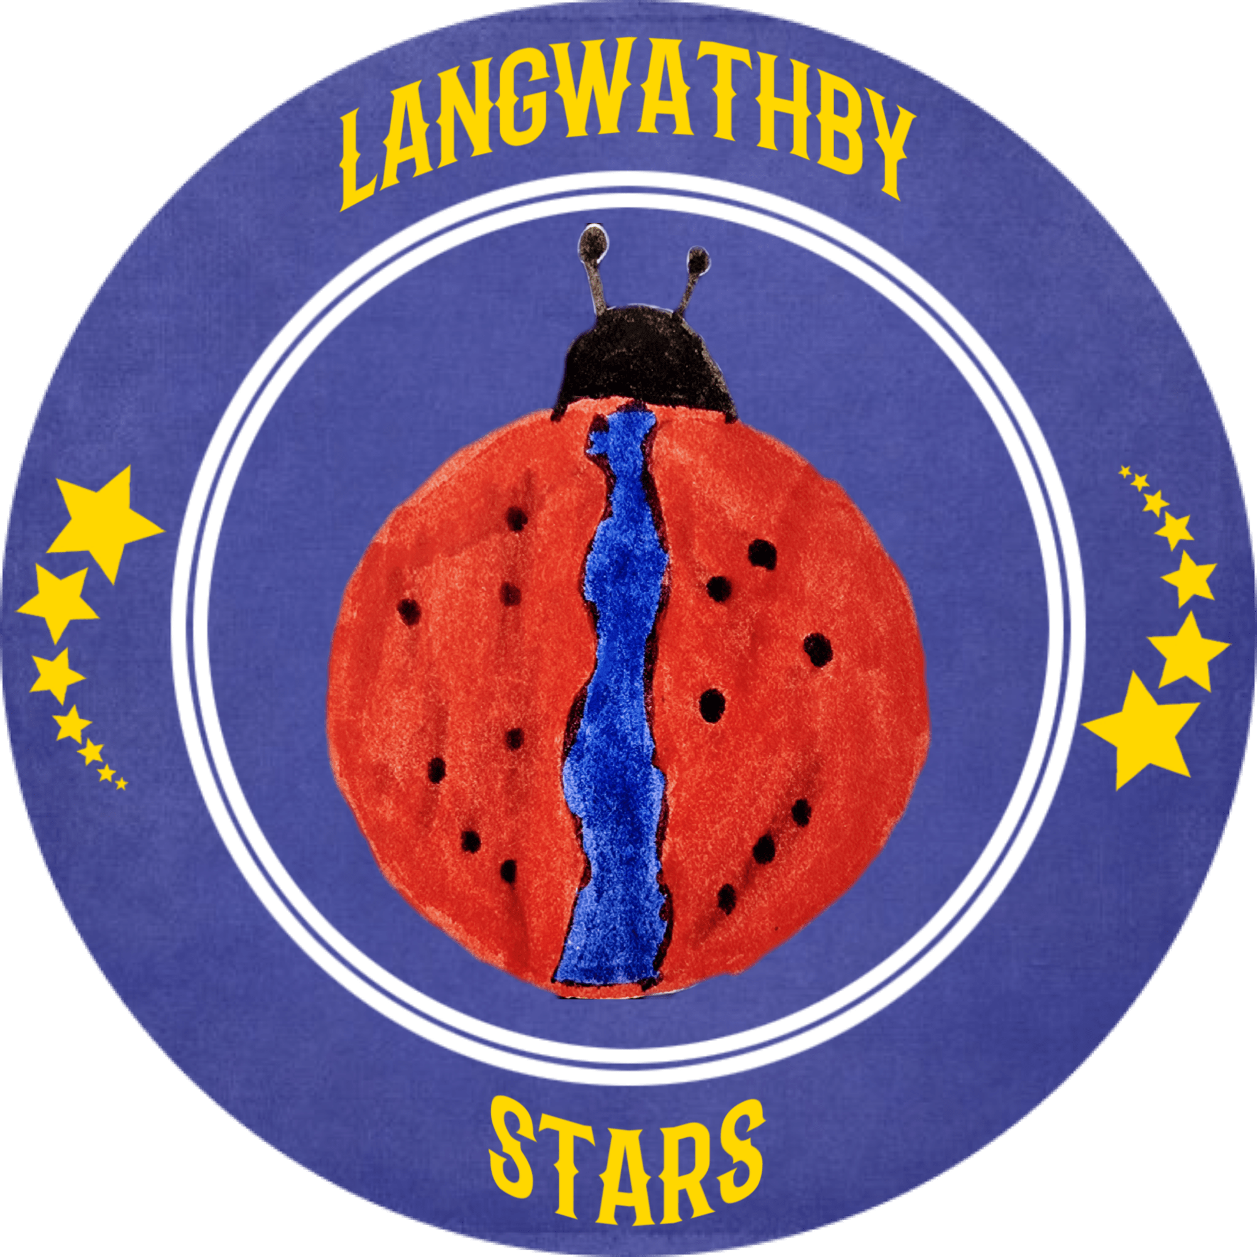One of our design team came up with this logo. They used a ladybird (because that’s our school logo and drew the River Eden down its back because it goes through Langwathby. We then used computers to create a cool circle around it.

Who do we need to tell? Who are the PEOPLE we need to PERSUADE? Who do we need to MARKET to?
We need to tell the parents of the acts so they can help them practise but also so they know when to come.
Where will we promote our campaign. Where will we PLACE it? How do we get PEOPLE who are interested to find what we’re doing?
We’re promoting it around the village and the school. It’s going to take place at school on the 7th of June.
Any other info we need (take a second piece of paper and draw more ideas if it helps):

How are we going to get the word out about our amazing business / social enterprise? What Is our PROMOTION? Are we making posters, are we using social media and our school website?
We will use school letters so it’s really official but also use some Facebook posts so people know about it. We’re also making posters to put up around the village.

If we need to tell someone about our business / social enterprise in ONE SENTENCE what words shall we use?
To help children at Langwathby School to show off their talents.

