Marketing Plan template

If we need to tell someone about our social enterprise and it’s PURPOSE in ONE SENTENCE what words shall we use? This could include a mission statement.
Our business ‘Cocoa House, a bite of joy… one bar could save a life’ is all about bringing people together and preventing loneliness.
Who do we need to tell? Who are the PEOPLE we need to PERSUADE? Who do we need to MARKET to? Who might benefit? We need to tell everyone in our community and market Cocoa House through posters, social media and our school newsletter.
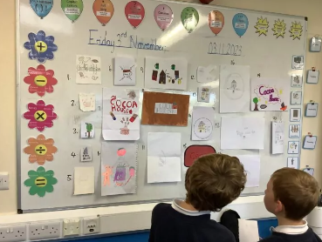
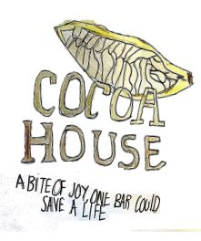
This is our final logo, we all created one and democratically voted for our favourite.
Do we want a
LOGO
(
picture) or something that tells people “visually” what we are doing? Square,
round….?? Draw some ideas here:


What is really special about what we are doing? What makes our PRODUCT (or service) stand out? Is it a service, is it helping PEOPLE, what difference does it make? Is it making a positive impact on a particular UN Global Sustainability Goal?
Our business is special because we are building on our community lunch initiative and trying to make school a hub for everyone in Seaton, somewhere people can share a smile and conversation in a warm environment.
UN Sustainable Development Goals:
We are focusing on the Good Health and Wellbeing goal because we want our school to be at the centre of the community to help our neighbours feel welcomed and never lonely. We want to invite them into school to make our community a happier place to live.
We are also focusing on Responsible Consumption and Production paired with Climate Change as we are aiming to make all our packaging recyclable and reusing cardboard thinking about the phrase reduce, reuse, recycle
What PRICE is it? Or if there isn’t a price, what VALUE does it have to local people?
The price of our products will range from 50p-£5 making it affordable to come together and this will make our community stronger by creating more bonds with the people in our village. The value to local people is helping everyone through the Christmas period with singing and a bit of cheer.
How are we going to get the word out about our amazing social enterprise? What Is our PROMOTION? This is where we could tell people as part of our promotion what our PURPOSE is and what change we want to see. Are we making posters, do we need to involve others, charities or other experts who could help us, are we using social media and our school website or even developing our own?
Our promotion will be through posters in the village, word of mouth from our parents and social media. We are going to advertise our coffee morning on Class Dojo, our school Facebook page and Age UK West Cumbria’s page to access the wider Workington area. We are involving AGE UK West Cumbria as they are our business mentors and have helped us to create and develop our business so far.

Where will we promote our campaign. Where will we PLACE it? How do we get PEOPLE who are interested to find what we’re doing or who might benefit?
Our campaign will be in the local shop windows in Seaton like the hairdressers, garage, one stop, Kowloon etc. We will interest people with our bright colourful posters and our promise of affordable tasty treats and Christmas presents.
Any other info we need (take a second piece of paper and draw more ideas if it helps):
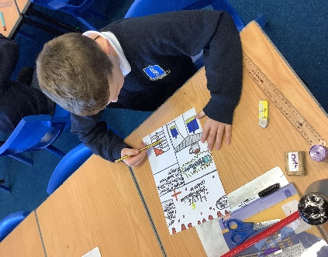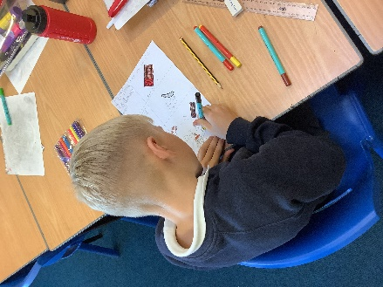

www.cforlp.org.uk

