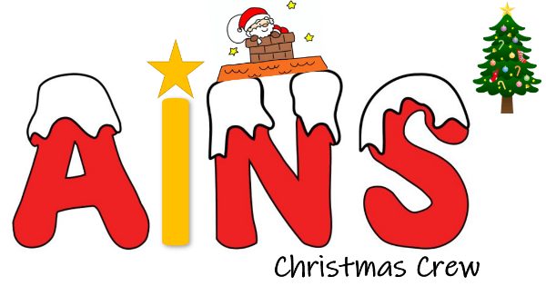
How are we going to get the word out about our amazing social enterprise? What Is our PROMOTION? This is where we could tell people as part of our promotion what our PURPOSE is and what change we want to see. Are we making posters, do we need to involve others, charities or other experts who could help us, are we using social media and our school website or even developing our own?
We are making posters that we will stick up around the school, we have advertised on our school facebook made and we have made some short promotional videos that we have posted on Tapestry (our online platform).

What is really special about what we are doing? What makes our PRODUCT (or service) stand out? Is it a service, is it helping PEOPLE, what difference does it make? Is it making a positive impact on a particular UN Global Sustainability Goal?
We are a forest school and all of our decorations will be made from natural materials we have collected from our forest. This also means that each one is unique. We feel it will have a positive impact on UN Sustainability goal 12 – Responsible consumption and production

Who do we need to tell? Who are the PEOPLE we need to PERSUADE? Who do we need to MARKET to? Who might benefit?
The children, parents and staff of our school.
Where will we promote our campaign. Where will we PLACE it? How do we get PEOPLE who are interested to find what we’re doing or who might benefit?
We are going to promote our campaign in school and on our social media platforms.
Any other info we need (take a second piece of paper and draw more ideas if it helps):

What PRICE is it? Or if there isn’t a price, what VALUE does it have to local people?
All our products are going to be £1 each.

If we need to tell someone about our social enterprise and it’s PURPOSE in ONE SENTENCE what words shall we use? This could include a mission statement.
To spread Christmas cheer to our school community with eco friendly Christmas decorations.
Do we want a LOGO (picture) or something that tells people “visually” what we are doing? Square, round….?? Draw some ideas here:

