Marketing Plan template

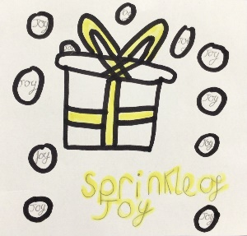


www.cforlp.org.uk
Do we want a LOGO (picture) or something that tells people “visually” what we are doing? Square, round….?? Draw some ideas here:
Where will we promote our campaign. Where will we PLACE it? How do we get PEOPLE who are interested to find what we’re doing or who might benefit? We will hold a whole school assembly to help spread the word. We will use school and PFA Facebook pages. At the coffee morning, some of us will speak about our mission and explain how they can help! We will also see if we can attend local events such as village fayres to help spread the word further! We will contact local businesses to see if they can help our mission and spread the word for us also. We will make sure we answer any questions people may have to make sure they fully understand and ask them to spread the word!
Any other info we need (take a second piece of paper and draw more ideas if it helps):
How are we going to get the word out about our amazing social enterprise? What Is our PROMOTION? This is where we could tell people as part of our promotion what our PURPOSE is and what change we want to see. Are we making posters, do we need to involve others, charities or other experts who could help us, are we using social media and our school website or even developing our own? We will use our school Facebook page as social media can be very powerful because so many people use it. We will create posters to advertise our coffee morning. We will put it in the local newsletter. Also we will choose a local charity to donate money to and hopefully they will help us to advertise our decorations, coffee morning and carol singing.
What PRICE is it? Or if there isn’t a price, what VALUE does it have to local people? Our decorations will range in price from £1 to £1.50. Our coffee morning will be free to attend to let people come together, talk and sing, cakes and coffee will be on sale. We will volunteer our time for free to carol sing around the village.
What is really special about what we are doing? What makes our PRODUCT (or service) stand out? Is it a service, is it helping PEOPLE, what difference does it make? Is it making a positive impact on a particular UN Global Sustainability Goal? Mental health and well being is something we feel is really important. We are focusing on UN Global goal 3 (good health and well-being). Everyone deserves to feel joyful and we want to help people who that is harder for, for whatever reason. Our aim is for people to give our decorations to someone who needs them: an elderly neighbour, someone they know is feeling lonely, the postman, a family member, anyone. Also our coffee morning and carol singing is our attempt to spread joy ourselves.
Who do we need to tell? Who are the PEOPLE we need to PERSUADE? Who do we need to MARKET to? Who might benefit? Persuade people (could be anyone) to buy our Christmas decorations to give them to someone they think might need some joy (particularly the elderly or people who may be lonely).

If we need to tell someone about our social enterprise and it’s PURPOSE in ONE SENTENCE what words shall we use? This could include a mission statement.
To support mental health and well-being by spreading some joy to people who need it in the local area this Christmas.

