Our BRIGHT STARS Social Enterprise Business Plan

School Name:
Gosforth C of E Primary School
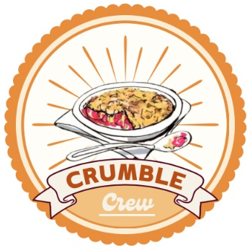
Social Enterprise Business Name:
Crumble Crew
What are you raising money for (cause/charity)?
Wasdale Mountain Rescue

1. Business Description
What is your business idea?

We are going to make crumbles every week for five weeks. We will have a different flavour each week. They will be sent home in foil containers and our customers will bake them at home.

Is it a product or a service?
This is a product.

2. Production
What do you need to be able to do it?
We will need the ingredients to make the product, containers with lids to send the product home in and order forms to take the orders. We will need a food preparation area.
3. Finances
What will you do with your £50?
Think creatively. Remember you can write to organisations to ask for free donations and can reinvest at any time
What will you spend your £50 on?
We will spend our £50 on ingredients and containers. We will shop around to get the right size container for the best price.

What will you charge for your product or service?
We worked out that each crumble will cost us approximately 45p to produce. We have decided to charge £3 for one crumble or £5 for two (people like an offer).

4. Marketing
Who are your customers?
Our customers are the parents of the children in school and the staff.

How will you advertise/ raise awareness of your social enterprise?
We will advertise on Class Dojo and send order forms out.

Where and when will you sell your product or service?
We will take orders and produce a crumble a week and send them home on a Wednesday.

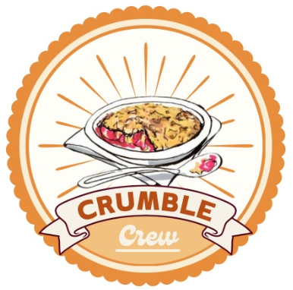
Will you design a logo or have a mission statement?

This is our logo. It is based on a drawing by Chloe.

5. Job roles
Who is going to do what? Who is in charge?
Our managing director is Adam. He has a personal assistant – Max.
Planner – Louis
Finance – Jack J, Isaac, Xander, Chloe
Marketing – Seb, Ryan, Jonathan, Jack B, Prya
Illustrator – Lilly
Sales – Catherine, Evie, Eleanor, Eva
Production – Nancy, Andrew, Charlie, Joseph

6. Make a difference
What difference will your social enterprise make to your school or your local community?
It will provide them with a tasty dessert to enjoy at home.

What UN Global Sustainability Goals does your social enterprise best fit with?
3 Good health and well-being
12 Responsible consumption and production

