With Vibes, we want to spread good vibes to our students.
We want to reassure and provide calm.

People – school community – parents and pupils. We will promote our product to parents and children. Parents can see how the resilience rocks will help to support children and children will want to have the latest, must have item.

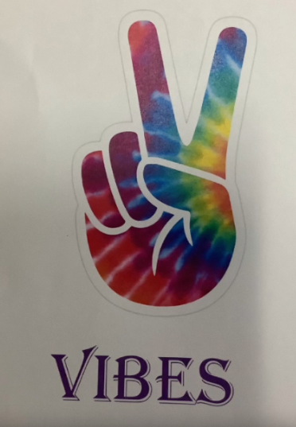
Logo – We experimented using clip art and online images to combine the peace sign with rainbow colours to spread good vibes.

Our Product & Price
- Story stones – A collection of themed stones for children to use when oral storytelling. £3.50
- Resilience Rocks – A little rock containing a positive message to remind children to keep trying. £1.50
- Reading Buddies – A little teddy buddy to read aloud to so children can gain confidence. £2.50

Promotion
- Posters
- Assembly Presentation
- Class Dojo Post for Parents

Place

- Sell at playtimes to our pupils
- Set up a stall at our open afternoon ‘Coffee and Chat’ to target parents

