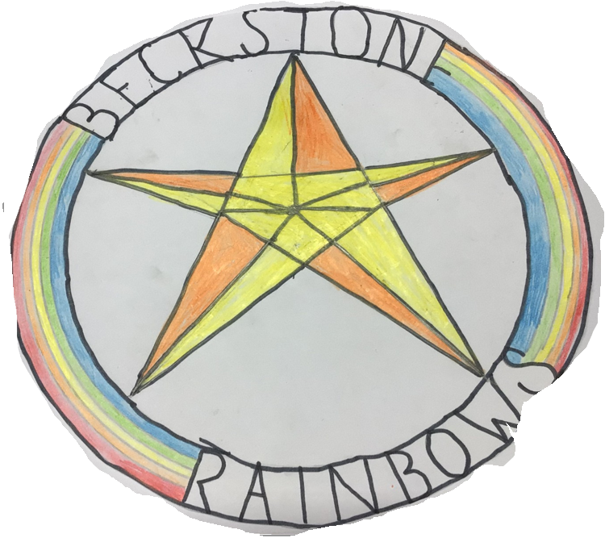
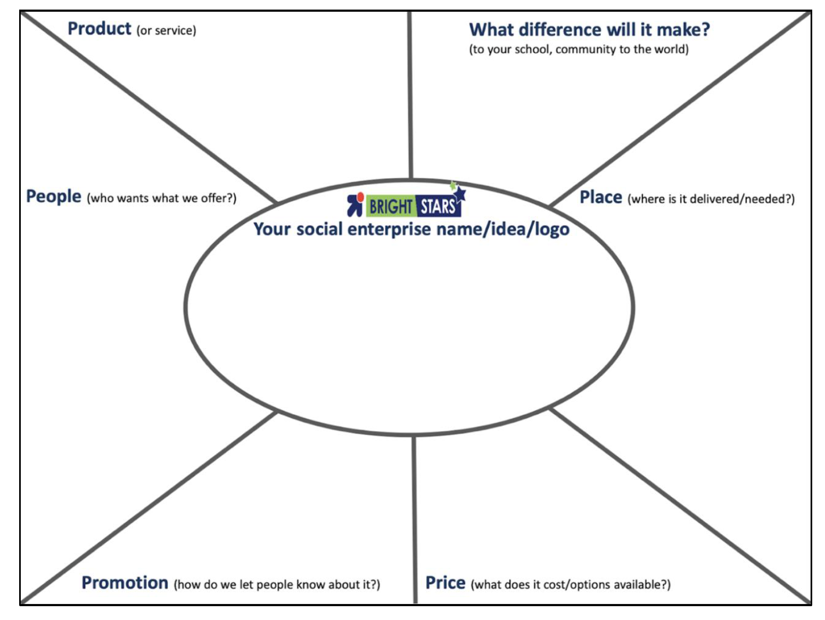
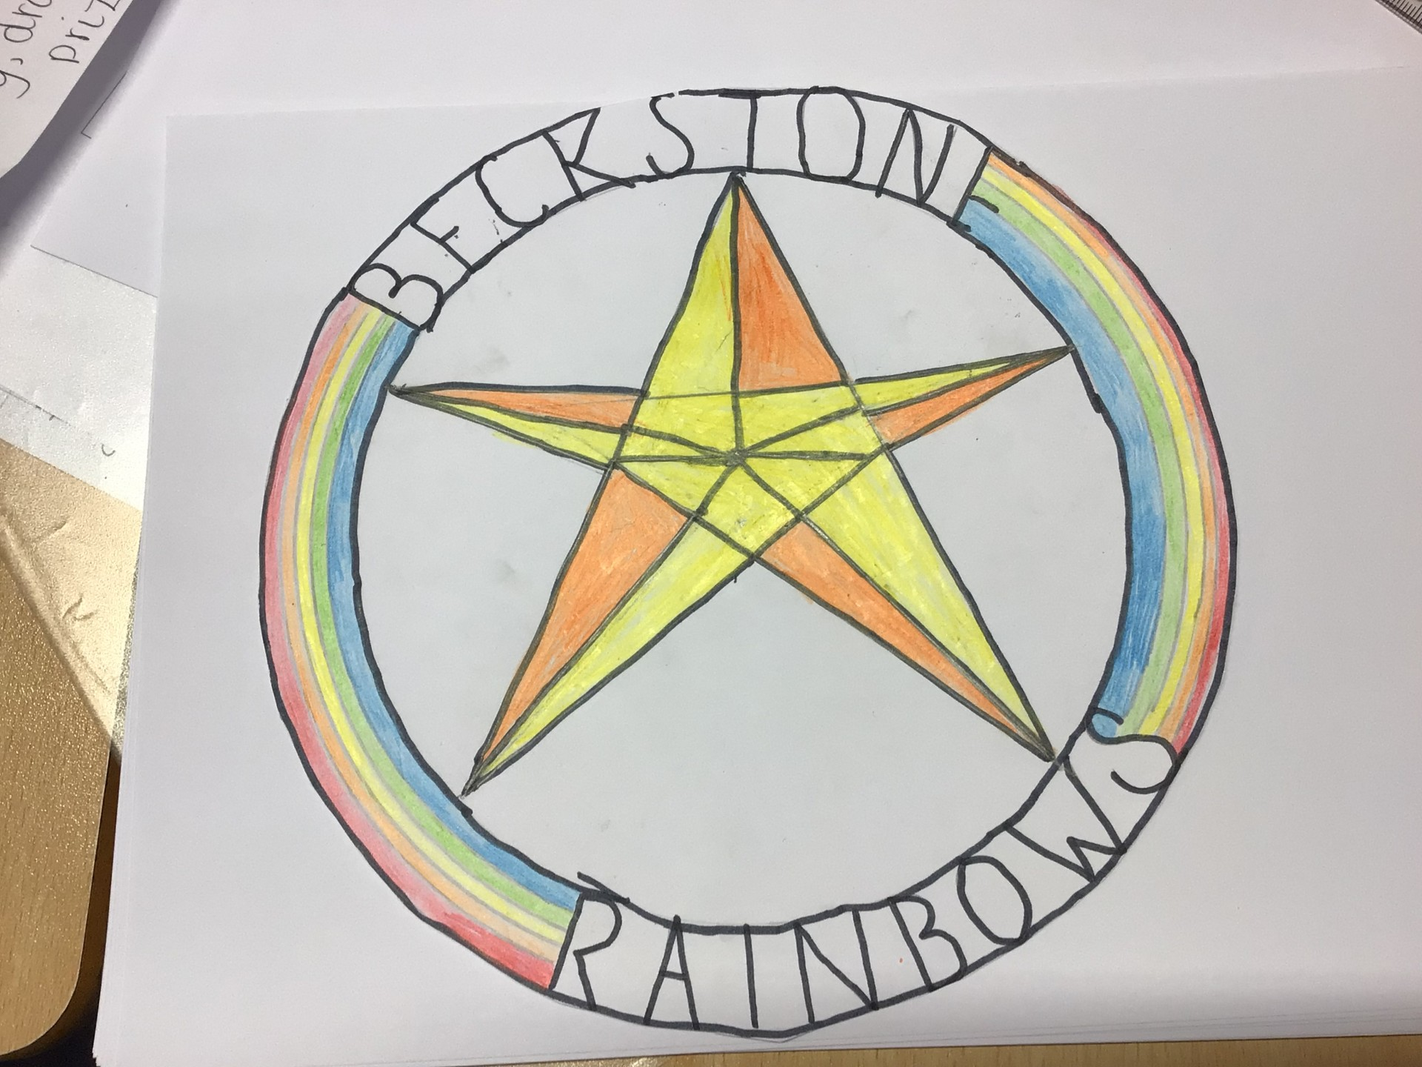
£1.50 – Halloween/Christmas sweet cones and clay bead bracelets
Halloween Craft Afternoon – Small pumpkin outline £2 Large outline - £4
£1.50 – Christmas reindeer Hot Chocolate Cones and Popcorn Cones.

Spooky Halloween Crafts
Cracking Christmas Crafternoon –Cracker making workshop.
-Pupils and families of Beckstone Primary School
-Local Community
-Staff members from the School
-Posters – put up around the school and presentation in assembly.
-Posters on Seesaw and Facebook
-Texts regarding product availability sent out to parents
-Items added to Parent Pay for easy access and fast payment for customers.

Beckstone Primary School
-Dining hall/Classroom – for craft afternoon
-Online – Parent pay

Half of our profits will support Cheer Force Knights on their journey to their third World Championships in Florida!
The other half will support improvements in our school, such as playground equipment.

