
WORKSHEET: Marketing plan template
(once completed this is submitted as a Week 9 report)

If we need to tell someone about our social enterprise and it’s PURPOSE in ONE SENTENCE what words shall we use? This could include a mission statement.
Our festival, ‘A Fest’, will make as much money as possible for the amazing St. Mary’s Hospice.

Who do we need to tell? Who are the PEOPLE we need to PERSUADE? Who do we need to MARKET to? Who might benefit?
We need to tell our pupils, parents and village community and persuade them to come to ‘A Fest’. Everyone who comes will benefit from a fun-filled afternoon of entertainment, cakes and biscuits, an exciting talent show and a variety of games.

Do we want a LOGO (picture) or something that tells people “visually” what we are doing? Square, round….?? Draw some ideas here:
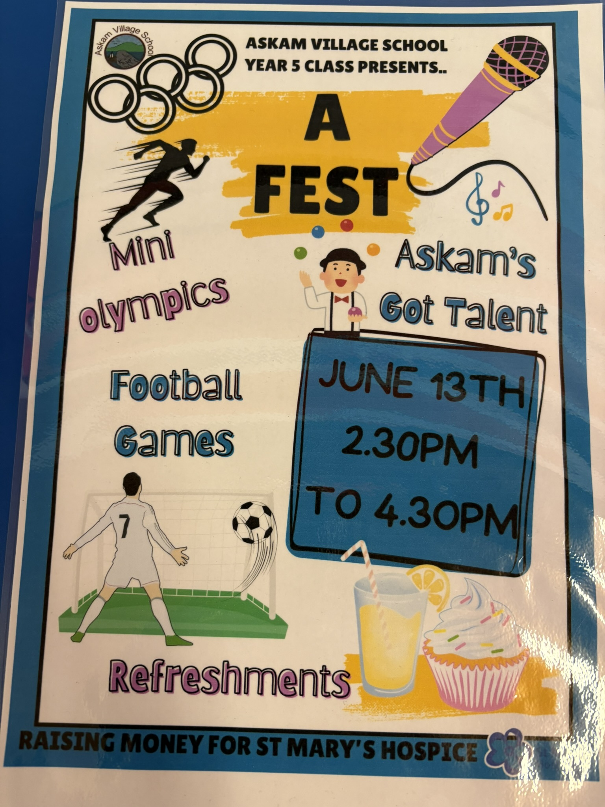

What is really special about what we are doing? What makes our PRODUCT (or service) stand out? Is it a service, is it helping PEOPLE, what difference does it make? Is it making a positive impact on a particular UN Global Sustainability Goal?
We hope to bring the whole school and village community together for our new ‘A Fest’ and hopefully begin what would be an annual fundraising event. We are giving pupils the chance to showcase their talents for an audience too. Our service is promoting well-being for all who attend.

What PRICE is it? Or if there isn’t a price, what VALUE does it have to local people?
It costs 50p each or £1 for a family to attend. It is a very special thing to bring together the whol village for such a lovely summer event. Fingers crossed for the sun to shine.

How are we going to get the word out about our amazing social enterprise? What Is our PROMOTION? This is where we could tell people as part of our promotion what our PURPOSE is and what change we want to see. Are we making posters, do we need to involve others, charities or other experts who could help us, are we using social media and our school website or even developing our own?
Posters, presentations about our activities in whole-school assemblies and the school Facebook page.
Where will we promote our campaign. Where will we PLACE it? How do we get PEOPLE who are interested to find what we’re doing or who might benefit?
Assemblies, school Facebook page and school entrances and exits.

Any other info we need (take a second piece of paper and draw more ideas if it helps):

