
WORKSHEET: Marketing plan template
(once completed this is submitted as a Week 9 report)

If we need to tell someone about our social enterprise and it’s PURPOSE in ONE SENTENCE what words shall we use? This could include a mission statement.
Save the environment by upcycling and recycling materials to create garden decorations.

Who do we need to tell? Who are the PEOPLE we need to PERSUADE? Who do we need to MARKET to? Who might benefit?
Young children who can learn about recycling and upcycling and how it helps our planet.
Visitors to Lingholm.
Our school families.
Do we want a LOGO (picture) or something that tells people “visually” what we are doing? Square, round….?? Draw some ideas here:
Madison is
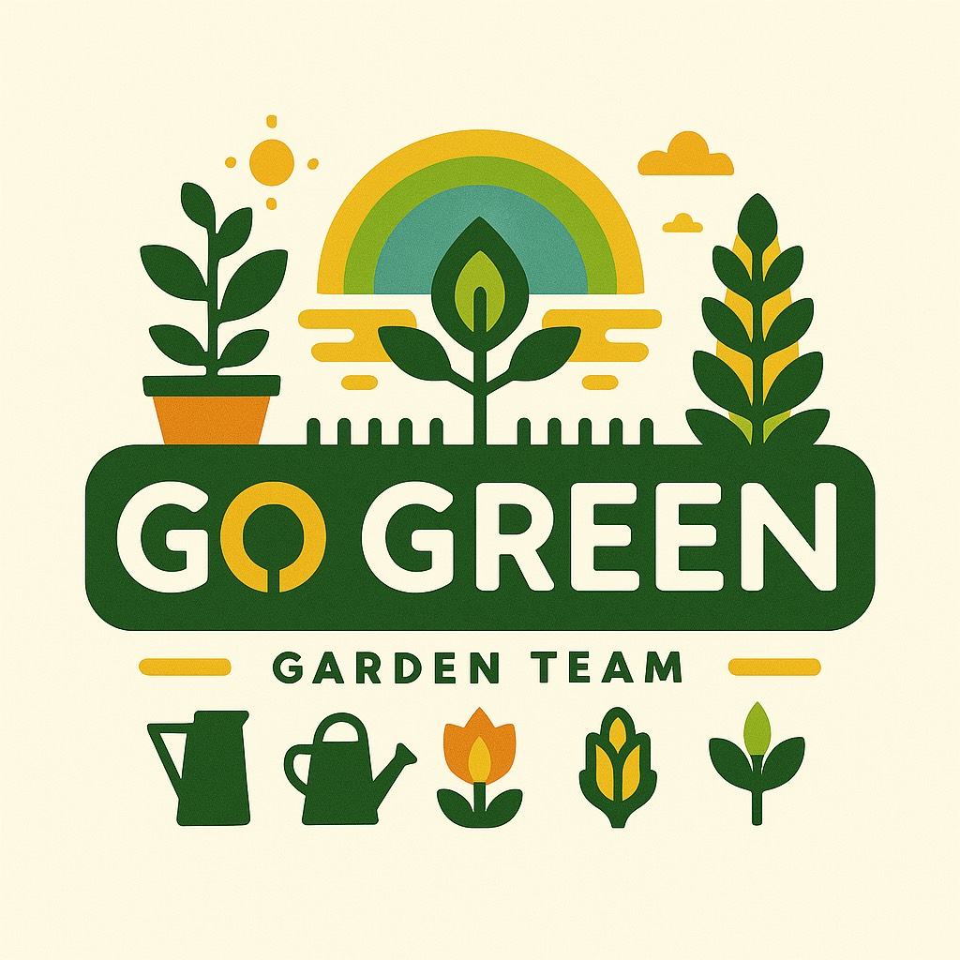

to make the logo.

What is really special about what we are doing? What makes our PRODUCT (or service) stand out? Is it a service, is it helping PEOPLE, what difference does it make? Is it making a positive impact on a particular UN Global Sustainability Goal?
Our product will make people consider their shopping habits and waste.
Our children will learn how to grow their own fruit and vegetables.

What PRICE is it? Or if there isn’t a price, what VALUE does it have to local people?
Various prices for our products and workshops.
Hopefully our school kitchen and our families can use the vegetables that we grow.
How are we going to get the word out about our amazing social enterprise? What Is our PROMOTION? This is where we could tell people as part of our promotion what our PURPOSE is and what change we want to see. Are we making posters, do we need to involve others, charities or other experts who could help us, are we using social media and our school website or even developing our own?
Facebook video.
Posters for the market stall.
Posters around school.
Mr Craig will tell people about it on the school newsletter.
Posters at Lingholm.
Where will we promote our campaign. Where will we PLACE it? How do we get PEOPLE who are interested to find what we’re doing or who might benefit?
Posters.
Facebook
Newsletters

Any other info we need (take a second piece of paper and draw more ideas if it helps):

