
WORKSHEET: Marketing plan template
(once completed this is submitted as a Week 9 report)

If we need to tell someone about our social enterprise and it’s PURPOSE in ONE SENTENCE what words shall we use? This could include a mission statement.
We wanted our spectacular Mr Bubble slime to make people smile, help us learn new skills and sell successfully for donations to Maryport Lifeboat Rescue.
Who do we need to tell? Who are the PEOPLE we need to PERSUADE? Who do we need to MARKET to? Who might benefit?

We learnt about target audiences in one of our sessions and decided that other Ewanrigg pupils and parents were the people we needed to market to.

We used posters, promoted our slime in assembly and even made an advert to market our slime. We wanted potential customers to realise that slime is fun to buy ‘on the spot’ and provides hours of fun but also makes a great gift if customers knew someone with a birthday coming up and it also contributes to a worthy cause so for customers it’s a ‘win-win’!

The week before we sold our slime, half our group also worked hard to decorate our selling stall with a huge banner and bright colours to catch attention of people passing by.

Do we want a LOGO (picture) or something that tells people “visually” what we are doing? Square, round….?? Draw some ideas here:
After a group talk about what we wanted our logo to look like, we decided we wanted to use our school logo for inspiration with a ‘Mr Bubble spin!’

We each drew our own versions for our art books then did a final version using all our ideas. We wanted it to be colourful, include slime splats, bubbles and be linked to our chosen charity!

We love it because customers can tell straight away that it resembles our school logo which we’re really proud of.
Our final logo:

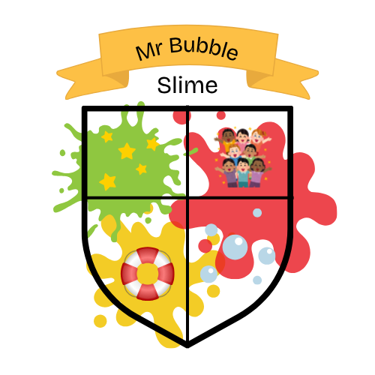

What is really special about what we are doing? What makes our PRODUCT (or service) stand out? Is it a service, is it helping PEOPLE, what difference does it make? Is it making a positive impact on a particular UN Global Sustainability Goal?

We think our business is really special because our product is one of a kind. We all love slime and buying it in toy shops but we haven’t found another handmade slime with so much effort and thought going into it.

We are really passionate about our chosen charity as some of our parents are involved with Maryport Lifeboat Rescue and so raising the money to donate has been really important for us. We knew we had to think of a product that other children would really want to buy and would bring lots of joy. We even bought little shapes and figures, like footballs and fish to go into the slime to make it truly special and everyone chose a different colour when making their slime to make sure it really stood out and each tub was one-of-a-kind.

What PRICE is it? Or if there isn’t a price, what VALUE does it have to local people?
We sold our slime for £3 per tub and our special slime splat biscuits were sold for 50p each.
How are we going to get the word out about our amazing social enterprise? What Is our PROMOTION? This is where we could tell people as part of our promotion what our PURPOSE is and what change we want to see. Are we making posters, do we need to involve others, charities or other experts who could help us, are we using social media and our school website or even developing our own?
As well as making posters to display around school, we also wanted to make sure we were promoting as much as possible via word of mouth.
We spoke to other pupils in assembly and filmed an advert so that customers could ‘meet the makers’ of our slime and get across everything that made our slime special. This also built our confidence as it involved lots of public speaking, teamwork and having to remember lots of important facts about the competition and our slime!
Where will we promote our campaign. Where will we PLACE it? How do we get PEOPLE who are interested to find what we’re doing or who might benefit?

Any other info we need (take a second piece of paper and draw more ideas if it helps):

As we knew it would be mainly children who would want to buy our slime, we made sure we told them about it directly in School. We also made pre-order forms, so that we made the right amounts to sell each week which also told parents at home about our slime and why we were making it.

We made sure that our slime was available to pick up after school, so that we had time to get our stall ready and we had lots of Bright Stars available to answer questions and persuade children to buy it outside of lesson/play time.

