WORKSHEET:
Business Plan (once completed this is submitted as a Week 9 report)

Our BRIGHT STARS Social Enterprise Business Plan
School Name: Ormsgill Nursery and Primary School

Social Enterprise Business Name: Buzz & Bloom

What are you raising money for (cause/charity)? Ormsgill Stronger Together

- Business Description
What is your business idea?
Aim to make a difference in our school and wider community. Our project focus will on two key areas: Environment – helping the bees and positive health and well-being – spreading kindness and positivity.

Is it a product or a service?
Products

- Production
What do you need to be able to do it?
Resources and time in school to create the products.

- Finances
What will you do with your £50?
Think creatively. Remember you can write to organisations to ask for free donations and can reinvest at any time
What will you spend your £50 on?

Flower biodegradable pots
Flower seeds/herb seeds
Compost
Silicone Bee Bracelets
Bee Charms

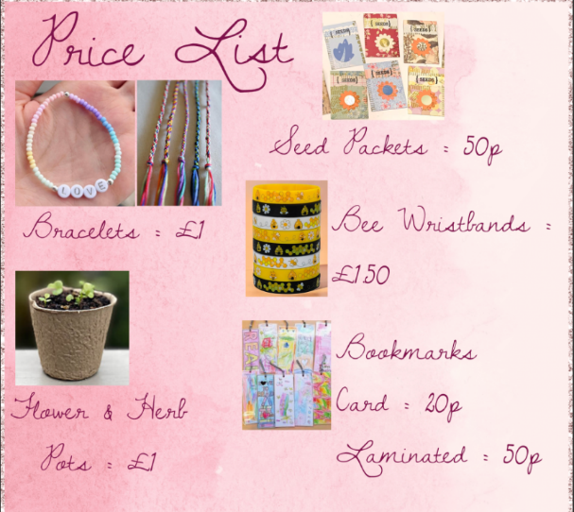
What will you charge for your product or service?

- Marketing
Who are your customers?
School children, staff and families, local community and the wider community (The bridge and Community Centre)

How will you advertise/ raise awareness of your social enterprise?
Social media, posters, word of mouth, video advertisement

Where and when will you sell your product or service?
In school, after school, in local community (booked sessions) and in wider community.

Will you design a logo or have a mission statement?
Yes – Buzz & Bloom

- Job roles
Who is going to do what? Who is in charge?

All the children applied for the roles suggested: Managing director, Head of production, Finance, Marketing Director, Business plan team, design team, customer service and Team marketing team.

We had groups within each role and all the children helped to create and sell our products.

- Make a difference
What difference will your social enterprise make to your school or your local community?
Spread positivity and kindness around school and the community. Help the bees within the community.

What UN Global Sustainability Goals does your social enterprise best fit with?

Good Health and well-being.
Climate Action
Life on land.

