
WORKSHEET: Marketing plan template
(once completed this is submitted as a Week 9 report)

If we need to tell someone about our social enterprise and its PURPOSE in ONE SENTENCE, what words shall we use? This could include a mission statement.

“SIP, SHOP, & SUPPORT”
Who do we need to tell? Who are the PEOPLE we need to PERSUADE? Who do we need to MARKET to? Who might benefit?

Members of the school community like parents, grandparents and friends. And the rest of the school community who will see the posters we put up to advertise our products to attract customers. We need to market this too target customers and put this on the school website/platform they use to make parents aware of what their children have been doing.
Do we want a LOGO (picture) or something that tells people “Visually” what we are doing? Square, round….?? Draw some ideas here: (logo attached)

Round Logo is below, with our social enterprise name and mission statement on:
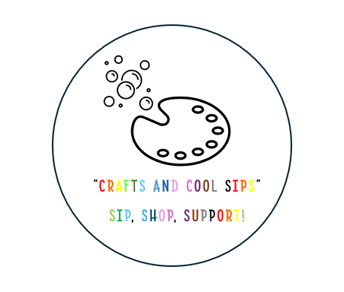
“Crafts and Cool Sips”
What is special about what we are doing? What makes our PRODUCT (or service) stand out? Is it a service, is it helping PEOPLE, what difference does it make? Is it making a positive impact on a particular UN Global Sustainability Goal?

Within our social enterprise we are selling products rather than offering a service. With a pocket pebble You can hold it, carry it, feel its weight. That makes the positive words feel more grounded and real.

Our social enterprise fits in with good health and wellbeing, as the pocket pebbles that the children are designing are designed with positive messages on hoping to make a positive impact on someone’s day

What PRICE is it? Or if there isn’t a price, what VALUE does it have to local people?

Our products we are offering vary prices depending on the product and how much effort and time they have took. The prices can vary from 50p - £2

How are we going to get the word out about our amazing social enterprise? What Is our PROMOTION? This is where we could tell people as part of our promotion what our PURPOSE is and what change we want to see.

Posters, emails, and spreading the word to parents and their friends etc through the schools use of website to keep the children’s parent in the loop about what they are doing. Poster shown below used to advertise:
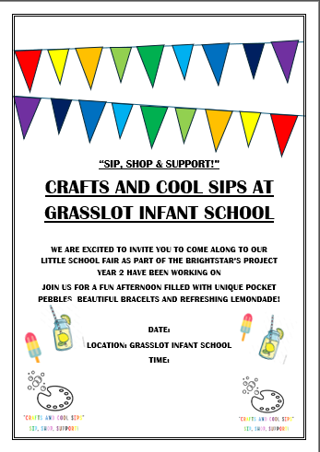
Where will we promote our campaign. Where will we PLACE it? How do we get PEOPLE who are interested to find what we’re doing or who might benefit?

We will put up posters around the school to catch other people’s eyes and parents’ eyes when collecting and picking up children from the school

