WORKSHEET:
Business Plan (once completed this is submitted as a Week 9 report)

Our BRIGHT STARS Social Enterprise Business Plan
School Name:
Grasslot Infant School

Social Enterprise Business Name:
“Crafts & Cool Sips”

What are you raising money for (cause/charity)?
The kids have decided they want to raise money for Cancer Research as many members of their families have been affected by cancer and have a member of staff currently undergoing treatment.

- Business Description
What is your business idea?
Collectively, we have decided to produce a little fair/stall where we are going to sell a few different handmade products. This way it was fair as everyone’s ideas got included for what they wanted to make. The children have decided to make bracelets, pocket pebbles with kind messages on and homemade lemonade and ice lollies.

Is it a product or a service?
Our idea is a product that we are going to sell to customers to make a profit and make a difference.

- Production
What do you need to be able to do it?
To be able to complete our idea successfully we will need
- Pebbles for our pocket pebbles that we are going down to the shore to collect
- Suitable pens to draw and write on the pebbles with so the colour and messages doesn’t come off easily.
- Loom bands and loom band kits for the bracelets
- Organza bags to put the bracelets in
- Ingredients to make homemade lemonade with

The children will also need a range of skills to not only help them succeed in the project but also help build their confidence and leadership for the future.
- Problem solving
- Innovation
- Decision making
- Teamwork
- Communication
- Time management

This way having these skills the children will all work together each having different roles within the project to be able to keep organised and stay within a time frame to complete the project on that deadline or even before with funds raised, and a difference made.

- Finances
What will you do with your £50?
We will invest our £50 funding from Brightstar’s into things that will help us to design our social enterprise and help us prepare in the best way possible.
What will you spend your £50 on?
We are going to spend some of our £50 on the appropriate pens to draw and write on our pebbles with, so that they don’t rub off easily and will stay on there, as well as buying ingredients for the lemonade.
What will you charge for your product or service?
For our products we are selling the price will differ due to the time and effort put in and quality of the products. The prices will vary from between 50p - £2.

- Marketing
Who are your customers?
We are aiming our product to the rest of the children and teachers at the school and hopefully attracting some of the parents to buy our products as well as we have a range of products suitable for different ages.

How will you advertise/ raise awareness of your social enterprise?
We have designed a poster to advertise our products that we are going to put up around the school to make people aware of what we are doing and when we are doing it. With the key info needed to attract customers to make a profit and a difference. Poster shown below:
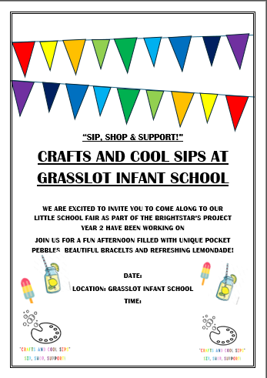

Where and when will you sell your product or service?
We are going to sell our product at Grasslot Infant school in Maryport so that it is local for the children and Imogen at Forth and the parents that are also going to come and visit.

Will you design a logo or have a mission statement?
As a class year 2 each designed their own logo and business name relating to what we are going to be selling, which Imogen then took away and developed their ideas putting some together to come up with our final logo and business name. Also including their mission statement, wanted something catchy that was going to attract customers. So, they decided on something with the same three letters, using alliteration. As shown below
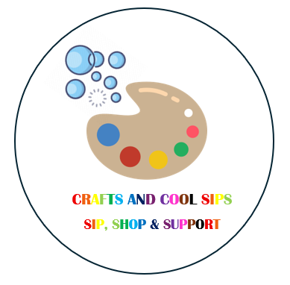

Paint pallet showing the colours and art to design the pocket pebbles and bubbles showing the lemonade as well as the name and mission statement showing.
- Job roles
Who is going to do what? Who is in charge?
During this project Imogen introduced job roles and responsibilities to the children, so they got a further understanding of what was required to make a successful business, so they could each have their own job role. The children got split into equal groups each for the different products we are going to sell one for lemonade, one for bracelets, one for pocket pebbles etc. In these groups the children have each discussed and decided who is going to have what job role following the job roles worksheet provided by Brightstar’s and explained why they wanted to be this job role and how they will impact the social enterprise by being in this role. As well as this each group has a designated leader who will keep them organised and communicate well to ensure they are on top of everything and working well together as team Although they have decided on a job role each we are still going to work together as a team to make sure our enterprise is as successful as it can be. And to help make a difference as much as we can.

- Make a difference
What difference will your social enterprise make to your school or your local community?
Our little social enterprise has helped the other students and staff at the school as during the warm weather we have had we have provided ice lollies and lemonade to ensure everyone stays hydrated during the nice weather we have had. As well as this our pocket pebbles had messages and drawings on that we hoped to brighten someone’s day with, supporting mental wellness and emotional resilience in the community. Giving them a range of different ones to choose from.
This social enterprise impacts the school as the students learn practical skills and creates a sense of pride and collaboration among the students as they are proud of what they have achieved for the first time doing something like this.

What UN Global Sustainability Goals does your social enterprise best fit with?
Our social enterprise fits in with good health and wellbeing, as the pocket pebbles that the children are designing are designed with positive messages on hoping to make a positive impact on someone’s day. As well as linking in with zero hunger and no poverty as we are offering a drink or ice lolly at a reasonable price for everyone.

