WORKSHEET:
Business Plan (once completed this is submitted as a Week 9 report)

Our BRIGHT STARS Social Enterprise Business Plan
School Name: Victoria Infant and Nursery School

Social Enterprise Business Name: Victoria Rainbows

What are you raising money for (cause/charity)?
- St. Matthew’s Community Halls

- Business Description
What is your business idea?
- Coffee Afternoon for Year 2 parents and group leaders from St. Matthew’s Community Halls
- Make and sell craft items – Salt dough Decorations and lollipop magnets

Is it a product or a service?
We are producing products to sell at a coffee afternoon
We are providing a service – coffee afternoon and group leaders from St. Matthew’s Community Halls are attending to give information/leaflets about the clubs etc that are on offer for the community

- Production
What do you need to be able to do it?
Ingredients for salt dough – salt and flour
Supplies for lollipop magnets – lollipop sticks and magnetic tape
Supplies for coffee afternoon – tea, coffee, cordial, biscuits, cakes, milk, sugar, paper plates, paper cups
- Finances
What will you do with your £50?
Think creatively. Remember you can write to organisations to ask for free donations and can reinvest at any time
What will you spend your £50 on?
Craft supplies and coffee afternoon supplies
Wrote to organisations for donations – Morrisons and Twist Tea gave donations

What will you charge for your product or service?
Salt dough decorations and lollipop magnets – 50p each
Tea bag pouches - £1 each
Cakes – 50p each
Raffle tickets - £1 a strip

- Marketing
Who are your customers?
Year 2 parents
Group leaders from St Matthew’s Community Halls

How will you advertise/ raise awareness of your social enterprise?
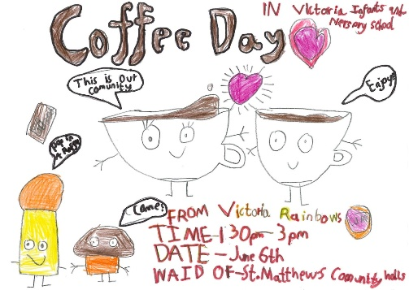
Poster
Facebook
Class dojo

Where and when will you sell your product or service?
Coffee Afternoon 6th June 1.30 – 3pm at Victoria Infant and Nursery School

Will you design a logo or have a mission statement?
We designed a group logo 

- Job roles
Who is going to do what? Who is in charge?

- All the children took part in the decision making, they all designed logos and posters that were then put to class votes.

- All the children produced products for the coffee afternoon

- Make a difference
What difference will your social enterprise make to your school or your local community?

We chose to donate half of our profits to the local community halls. Group leaders that use the community halls were invited to attend the coffee afternoon so they could meet parents and discuss what clubs are on offer. We also created a PowerPoint to display at the coffee afternoon with details about the services that the halls provide.

Going forward we are hoping to develop closer links with the community halls and the groups that use the halls.

What UN Global Sustainability Goals does your social enterprise best fit with?

Goal 3 - Good Health and Well-Being – The community Halls that we supported provides groups that encourage and promote health and well-being – including mental health.

