Marketing plan
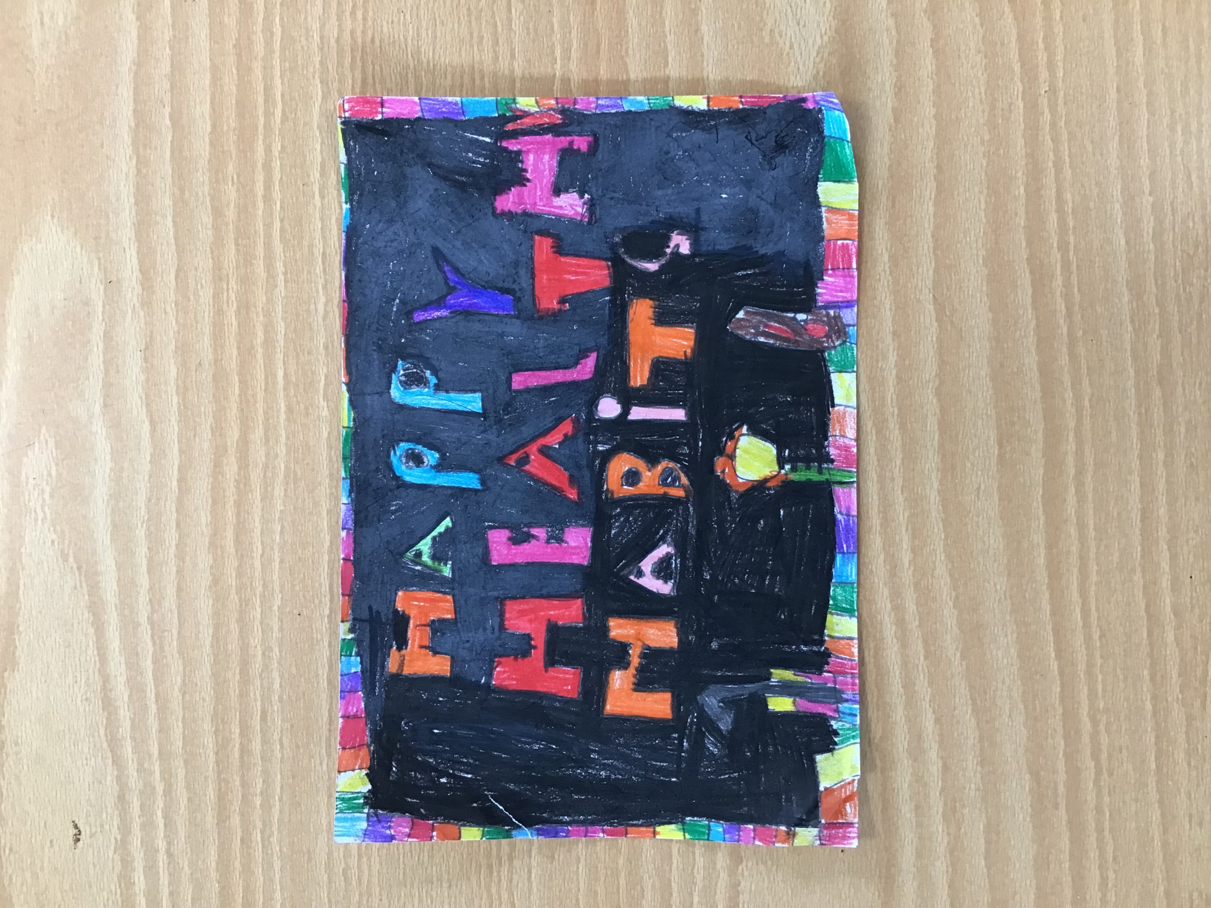
We made flyers with our very own logo on there to promote our business and show people who we are. We gave these out to grown ups and stuck them up around school. The posters had all of the relevant information on including; when and where we were selling our products and what we were selling. Our grown-ups also received an order form, so they could place their order in advance and were aware of when the sale was.

