WORKSHEET:
Business Plan (once completed this is submitted as a Week 9 report)

Our BRIGHT STARS Social Enterprise Business Plan
School Name:
Hensingham Primary School

Social Enterprise Business Name:
Hensingham Helpful Elves

What are you raising money for (cause/charity)?
Young Minds

- Business Description
What is your business idea?
We are providing fun Christmas activities for all to enjoy. We are going to create a Christmas Fair and invite all the children and adults connected to Sycamore Class to come for some Christmas fun.

Is it a product or a service?
It is a service.

- Production
What do you need to be able to do it?
The hall.
Tables.
Ideas for games that don’t need many resources to buy.
Write letters for donations of prizes.
Paper, paint, tickets, and other classroom resources like glue.
(Borrow) Christmas costumes
(Borrow) PE equipment for find the penguin and throwing snowball games.

- Finances
What will you do with your £50?
Think creatively. Remember you can write to organisations to ask for free donations and can reinvest at any time
What will you spend your £50 on?

Paper
Paint – red, brown, black
Glue
Glitter

What will you charge for your product or service?

We will use tickets for people to play games and children need to pay £1 per 5 tickets. We will allow children without tickets to do free activities so they can come down with their class,

- Marketing
Who are your customers?
Children in the school and adults connected to Sycamore Class.

How will you advertise/ raise awareness of your social enterprise?
Letters and posters.

Where and when will you sell your product or service?
The afternoon of Monday December 8th. Adults can come from 2.45pm

Will you design a logo or have a mission statement?
We have designed a logo.
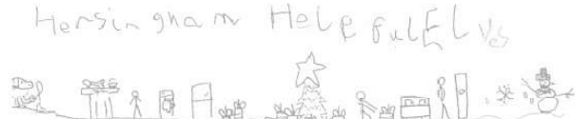
Our mission statement is:
“We wish to bring joy and cheer at this time of year.”

- Job roles
Who is going to do what? Who is in charge?
We will all be stall holders and will be in charge of our own stalls. We will all make posters for our different stalls and write a letter to our adults at home to help with donations. Class teachers will collect money for the children buying tickets and adults will donate what they want at the stalls or by giving it to the children to bring in in the morning.

- Make a difference
What difference will your social enterprise make to your school or your local community?
It will bring the community together for fun things to do and invite adults into the school for a fun activity. If we enjoy it, we can do it again at different times of year.

What UN Global Sustainability Goals does your social enterprise best fit with?

Goal 3: "Good Health and Well-Being," aiming to ensure healthy lives and promote well-being for everyone at all ages.

