
WORKSHEET: Marketing plan template
(once completed this is submitted as a Week 9 report)

If we need to tell someone about our social enterprise and it’s PURPOSE in ONE SENTENCE what words shall we use? This could include a mission statement.
Our project is all about raising money to help give young people important heart checks by working together and being creative.
Who do we need to tell? Who are the PEOPLE we need to PERSUADE? Who do we need to MARKET to? Who might benefit?
We need to tell parents, families, and our school community about our project. We aim to persuade potential donors and supporters to get involved and market our efforts to the school community. Those who will benefit most are young people in the local area and their families, through access to life-saving heart screenings.
Do we want a LOGO (picture) or something that tells people “visually” what we are doing? Square, round….?? Draw some ideas here:
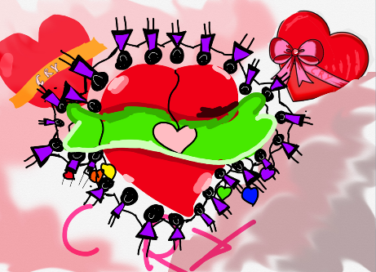
What is really special about what we are doing? What makes our PRODUCT (or service) stand out? Is it a service, is it helping PEOPLE, what difference does it make? Is it making a positive impact on a particular UN Global Sustainability Goal?
What makes our project special is that it will turn creativity and teamwork into real-life impact. Starting with just £50, we aim to raise enough to fund heart screenings for young people, helping to save lives and give families peace of mind. Our social enterprise will focus on helping people and making a positive difference, supporting the UN Goal for Good Health and Well-Being.

What PRICE is it? Or if there isn’t a price, what VALUE does it have to local people?
- Tree decorations – 50p/£1
- Bracelets - £1
- Bookmarks – 50p
- Biscuits – 50p
- Non-uniform + a gift bag – 50p
How are we going to get the word out about our amazing social enterprise? What Is our PROMOTION? This is where we could tell people as part of our promotion what our PURPOSE is and what change we want to see. Are we making posters, do we need to involve others, charities or other experts who could help us, are we using social media and our school website or even developing our own?
We promoted our social enterprise by creating eye-catching posters to share our purpose and the change we wanted to see, and by delivering a special assembly to explain our project to the school community. This helped everyone understand that our goal was to raise money for heart screenings to keep young people healthy and safe. We also invited a local representative from the CRY charity who is a former member of staff to the event.
Where will we promote our campaign. Where will we PLACE it? How do we get PEOPLE who are interested to find what we’re doing or who might benefit?
Posters around school and on our school parents’ groups.
We also sent letters to our local Tesco and Co-op to ask for donations of biscuits for our event.

Any other info we need (take a second piece of paper and draw more ideas if it helps):

