
WORKSHEET: Marketing plan template
(once completed this is submitted as a Week 9 report)

If we need to tell someone about our social enterprise and it’s PURPOSE in ONE SENTENCE what words shall we use? This could include a mission statement.
Creation of science garden for Beckermet School students.
Who do we need to tell? Who are the PEOPLE we need to PERSUADE? Who do we need to MARKET to? Who might benefit?
School staff, parents/carers in order to support and contribute to the creation and running of science garden.
Do we want a LOGO (picture) or something that tells people “visually” what we are doing? Square, round….?? Draw some ideas here:
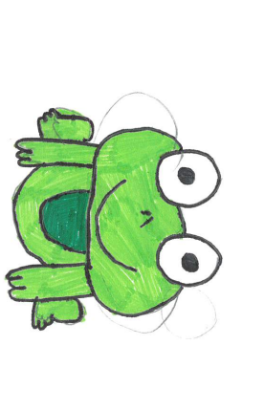

What is really special about what we are doing? What makes our PRODUCT (or service) stand out? Is it a service, is it helping PEOPLE, what difference does it make? Is it making a positive impact on a particular UN Global Sustainability Goal?

A service to help students understand the natural environment and different aspects of the Science curriculum such as, development and growth of animals, the water cycle, growth of plants, biodiversity and a sensory approach to plant growth.

What PRICE is it? Or if there isn’t a price, what VALUE does it have to local people?
Educational value to students + opportunity to expand and use by the public (nursery).
How are we going to get the word out about our amazing social enterprise? What Is our PROMOTION? This is where we could tell people as part of our promotion what our PURPOSE is and what change we want to see. Are we making posters, do we need to involve others, charities or other experts who could help us, are we using social media and our school website or even developing our own?
Posters. ClassDojo. Word of mouth.
Where will we promote our campaign. Where will we PLACE it? How do we get PEOPLE who are interested to find what we’re doing or who might benefit?

Within school and online safe social media.
Any other info we need (take a second piece of paper and draw more ideas if it helps):

N/A

