WORKSHEET:
Finance Plan (once completed this is submitted as a Week 9 report)

How to keep track of the money in the social enterprise business
Team Name: Ormsgill Nursery and Primary School
Social Enterprise Business name: Busy Bees
Starting money: £50
EXPENDITURE (what we have to spend to buy stock, tools, equipment etc).
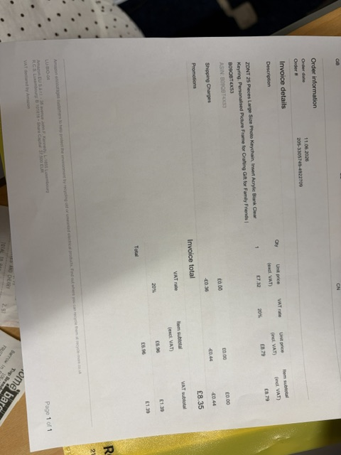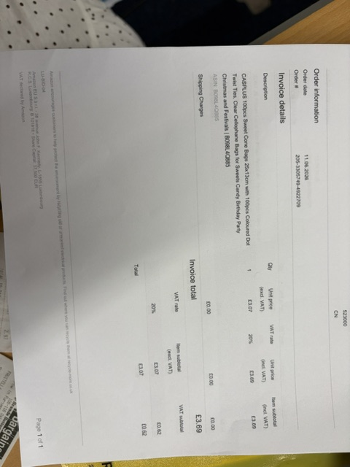
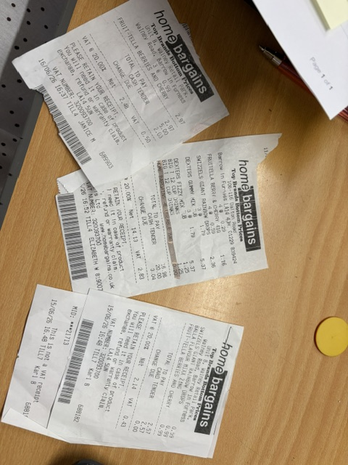
INCOME (Money that comes in when we sell our items or deliver our service).

Sweet cones 50p-£1.50
Juice cups 50p
Posters £1
Keyrings £2
Hand (face) paint 50p
Glitter tattoos 50p

= £216.70 + £15.66 remaining budget = £232.36

£232.36 - £30 float (school cash) = £202.36

£202.36 - £50 (starting amount) = £152.36

£152.36 ÷ 2 = £76.18
Starting money £ 50.00
Minus -

Expenditure (costs) £ 34.34
Plus +

Income (sales) £ 202.36
Equals =

Profit (good if +, not so good if -) +£152.36

