
WORKSHEET: Marketing plan template
(once completed this is submitted as a Week 9 report)

If we need to tell someone about our social enterprise and it’s PURPOSE in ONE SENTENCE what words shall we use? This could include a mission statement.
We are starting a social enterprise to promote positivity and joy within our school and local community.
Bee Kind, Bee Respectful, Bee Yourself, Bee Amazing
Who do we need to tell? Who are the PEOPLE we need to PERSUADE? Who do we need to MARKET to? Who might benefit?
We need to tell people within our school and local community. We did not limit the age range because everybody, no matter your age, needs positivity in their life! Our posters that we used for advertisement were aimed at adults and children of all ages.
Do we want a LOGO (picture) or something that tells people “visually” what we are doing? Square, round….?? Draw some ideas here:
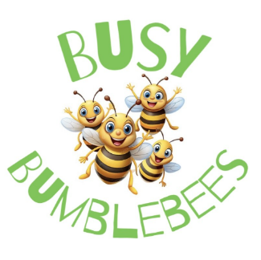
We all had lots of different ideas and drew them our on paper, considering what makes a good logo (Lottie helped us learn all about this) and then we had a vote. We decided to keep our logo simple so that people remembered our business name and incorporated the bees from our school uniform. After our voting was complete, somebody from the design team used Pic Collage to create it and we printed it onto stickers to stick on our products!

What is really special about what we are doing? What makes our PRODUCT (or service) stand out? Is it a service, is it helping PEOPLE, what difference does it make? Is it making a positive impact on a particular UN Global Sustainability Goal?

Our product stands our because we worked hard to make everything by hand, thinking carefully about the right things to say, the right designs and colours to use and the right pricing to make it affordable. Mental health is such an important thing and staying positive isn’t always easy.
Our product makes the most impact on the UN Global Sustainability Goal number 3, Good Health and Well-being.

What PRICE is it? Or if there isn’t a price, what VALUE does it have to local people?

Sweet cones 50p-£1.50
Juice cups 50p
Posters £1
Keyrings £2
Hand (face) paint 50p
Glitter tattoos 50p

We tried to make our prices fair and affordable, whilst also making profit!
How are we going to get the word out about our amazing social enterprise? What Is our PROMOTION? This is where we could tell people as part of our promotion what our PURPOSE is and what change we want to see. Are we making posters, do we need to involve others, charities or other experts who could help us, are we using social media and our school website or even developing our own?

Where will we promote our campaign. Where will we PLACE it? How do we get PEOPLE who are interested to find what we’re doing or who might benefit?

Our marketing team handed our posters out to class teachers across the school to advertise our final sale, our teacher posted it on Dojo (our school communication platform) and our admin staff posted it on the newsletter. We also spent A LOT of time telling our friends and family outside of school about what we were doing!

Any other info we need (take a second piece of paper and draw more ideas if it helps):

