
WORKSHEET: Marketing plan template
(once completed this is submitted as a Week 9 report)

If we need to tell someone about our social enterprise and it’s PURPOSE in ONE SENTENCE what words shall we use? This could include a mission statement.
Our mission is to work together, use our creativity and raise as much money as possible to support Mountain Rescue and make a positive difference in our community. With our kindness, we can move mountains.
Who do we need to tell? Who are the PEOPLE we need to PERSUADE? Who do we need to MARKET to? Who might benefit?
Before we started our fundraising, we knew we needed to tell lots of different people about our business and events. This included parents and carers, pupils, teachers, school staff, Oxley’s employees and local businesses. We also planned to use Facebook and school newsletters to reach the wider community.
We knew we would need to persuade parents to buy tickets and cakes, families to attend our Movie Night and local businesses to donate items to support our fundraising. We also hoped that Oxley’s staff, school staff and pupils would support our events and help us raise as much money as possible.
To market our business, we planned to target families at Victoria Academy, school staff, local businesses, Oxley’s employees and members of the local community. We wanted to reach anyone who might be interested in supporting Mountain Rescue.
We hoped our fundraising would benefit Mountain Rescue by helping to fund their important work. We also thought it would help us learn about business, teamwork and leadership, while inspiring other children in our school to take on their own enterprise projects in the future.

Do we want a LOGO (picture) or something that tells people “visually” what we are doing? Square, round….?? Draw some ideas here:
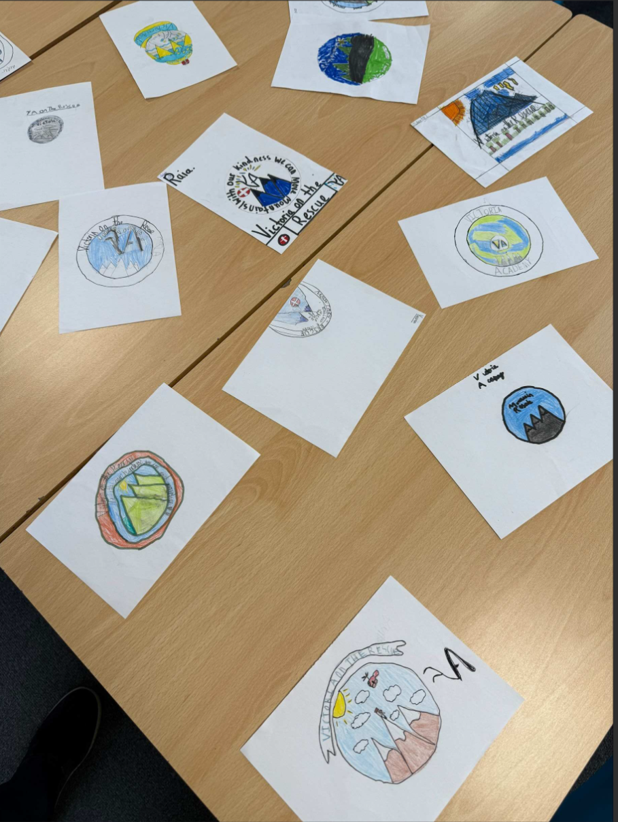

What is really special about what we are doing? What makes our PRODUCT (or service) stand out? Is it a service, is it helping PEOPLE, what difference does it make? Is it making a positive impact on a particular UN Global Sustainability Goal?
What is really special about our business is that we are not just trying to make money – we are trying to make a difference. Through our cake sales and Movie Night, we are raising money for Mountain Rescue, a charity that helps people when they are lost, injured or in danger outdoors.
Our service stands out because it brings people together to support an important cause. Every cake sold and every ticket bought helps Mountain Rescue continue their life-saving work. As children, we have planned and run our own business, showing that young people can make a positive impact in their community.
Our project links closely to the United Nations Sustainable Development Goal 3: Good Health and Well-being. By supporting Mountain Rescue, we are helping an organisation that keeps people safe and provides emergency assistance when it is needed most. We are also promoting teamwork, community spirit and helping others, which has had a positive impact on our school and local community.

What PRICE is it? Or if there isn’t a price, what VALUE does it have to local people?
£2 for the movie night.
20p-£1.50 for snacks at the movie night.

50p-£1 for the cakes at the cake sale.
How are we going to get the word out about our amazing social enterprise? What Is our PROMOTION? This is where we could tell people as part of our promotion what our PURPOSE is and what change we want to see. Are we making posters, do we need to involve others, charities or other experts who could help us, are we using social media and our school website or even developing our own?
We will use social media, posters and letters to promote our business and fundraising events. These will help us reach parents, pupils, staff and members of the local community. As well as raising money for Mountain Rescue, we also want to spread awareness about staying safe when hiking and exploring outdoors. By sharing safety messages and information about the important work Mountain Rescue does, we hope to encourage people to be prepared, stay safe and enjoy the outdoors responsibly.
Where will we promote our campaign. Where will we PLACE it? How do we get PEOPLE who are interested to find what we’re doing or who might benefit?

We will place our campaign on social media and use posters around school and in the local community to help spread our message. This will allow us to reach a wide range of people, including parents, pupils, staff and local businesses. By advertising our events and sharing information about Mountain Rescue, we hope to encourage more people to support our fundraising and learn about the importance of staying safe outdoors.
Any other info we need (take a second piece of paper and draw more ideas if it helps):

