Marketing Plan template
Do we want a LOGO (picture) or something that tells people “visually” what we are doing? Square, round….?? Draw some ideas here:

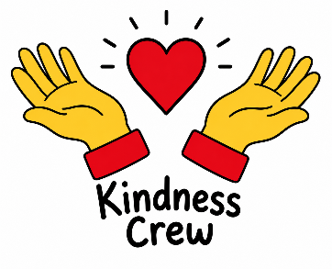

What is really special about what we are doing? What makes our PRODUCT (or service) stand out? Is it a service, is it helping PEOPLE, what difference does it make? Is it making a positive impact on a particular UN Global Sustainability Goal?
Our project is special because it is all about kindness and community. Rather than simply raising money, we are creating practical kindness kits that will directly support homeless people with essential everyday items while also showing compassion and care for people who may feel that no one is thinking about them. Our product stands out because it is being led by young people, giving children the opportunity to make a real difference to the lives of others while developing empathy, teamwork and social responsibility. The project makes a positive difference by helping meet immediate needs such as hygiene and basic care. Goal 3: Good Health and Wellbeing – by supporting the physical and emotional wellbeing of homeless individuals.

What PRICE is it? Or if there isn’t a price, what VALUE does it have to local people?
After working out how much it would cost for the toiletries for each bag we worked out we need £8. This would buy shampoo, deodorant, shower gel, toothbrush and toothpaste, razors and hand cream. The pocket hearts and cards will be hand made.

Where will we promote our campaign. Where will we PLACE it? How do we get PEOPLE who are interested to find what we’re doing or who might benefit?
We will advertise on ClassDojo. We will add photographs of examples of what the Kindness Kits look like. We will also let the pupils know the kinds of things that will be on offer at the Bits and Pieces sale.


www.cforlp.org.uk
How are we going to get the word out about our amazing social enterprise? What Is our PROMOTION? This is where we could tell people as part of our promotion what our PURPOSE is and what change we want to see. Are we making posters, do we need to involve others, charities or other experts who could help us, are we using social media and our school website or even developing our own?
We will use ClassDojo and our logo to advertise our product. We will send a sponsor form when we are ready, and parents can pay cash or can bank transfer. The funds will then be used to make up more Kindness Kits.
We will make posters to advertise the Bits and Pieces sale and put them up around school.
Who do we need to tell? Who are the PEOPLE we need to PERSUADE? Who do we need to MARKET to? Who might benefit?
We need to tell our parents as we hope they will sponsor a bag. We can do this on ClassDojo.
If we need to tell someone about our social enterprise and it’s PURPOSE in ONE SENTENCE what words shall we use?
We created a business that would provide Kindness Kits to Calderwood House in Egremont so the residents can have essential toiletries and know that someone is thinking about them.

