WORKSHEET:
Business Plan (once completed this is submitted as a Week 9 report)

Our BRIGHT STARS Social Enterprise Business Plan
School Name:
Maryport Church of England Primary School
Social Enterprise Business Name:
Forth Engineering
What are you raising money for (cause/charity)?
Knoxwood Wildlife Rescue is a wildlife sanctuary and rescue centre that helps injured wild animals and birds, including unusual rescue cases. It is based near Wigton and also runs a charity shop in Maryport to raise money for its work.

- Business Description
What is your business idea?
Our business idea is to create and sell handmade sock monkeys, along with running sock monkey workshops where children and their families can come into school and make their own.
Is it a product or a service?
It is mainly a produce as we are selling the finished sock monkeys. However, there is an element of service as we will provide workshops where people take part in making them.
- Production
What do you need to be able to do it?
To be able to do it, we need materials such as socks, stuffing, buttons, thread, as well as basic sewing equipment like needles and thread. We also need a suitable space in school to run the workshops, such as the hall and support from staff and possibly volunteers to help supervise and guide the children and families. In addition, we need good organisation and planning to make sure the sessions run smoothly and safely.

- Finances
What will you do with your £50?
Think creatively. Remember you can write to organisations to ask for free donations and can reinvest at any time
What will you spend your £50 on?
We would spend our £50 on buying essential materials to make the sock monkeys, such as socks, stuffing, buttons, thread and fabric pens. We would also set some of the money aside for basic sewing equipment like needles, glue and scissors if needed. We could use any money left for drinks and snacks to sell at the family workshop.
We could also create a bake sale when the workshop is happening to raise extra funds, so we would use the money on baking equipment. We could also put an appeal out for cakes to sell to save money.
As the children are making instruction booklets upon how to look after a sock monkey and an adoption certificate the money could be used to print these off to sell.
To be more creative and cost-effective, we could ask families for donations of materials, which would help us stretch our budget further.
Any money saved could be reinvested into making more sock monkeys or improving the workshop experience.
What will you charge for your product or service?
£5 per sock monkey pack.
- Marketing
Who are your customers?
Our main customers are:
- Children (primary school age)
- Parents and families
- Our school
We could also target:
- People looking for unique handmade gifts
- Craft lovers who enjoy workshops (families across the school)
How will you advertise/ raise awareness of your social enterprise?
- Creating posters and putting them up around school
- Using social media (e.g. Facebook) to show our sock monkeys
- Running a demo workshop at school
- Asking teachers to put on their Seesaw accounts
- On the school newsletter to spread the word
- Word of mouth (friends telling others)
- Share photos/videos of the making process
- Show happy customers with their finished sock monkeys
Where and when will you sell your product or service?
Where:
- In the school main entrance for all classes to access
- In year 2 class
- Possibly local/community area
When:
- During school events (e.g. the workshop)
- Morning before school, break, lunch and even after school.
Will you design a logo or have a mission statement?
Logo idea: A cute, simple sock monkey face with bright colours using AI (ChatGPT).
Mission statement: Our purpose is to help protect animals in danger in Maryport by raising money through selling sock monkeys for a local charity that keeps animals safe.

- Job roles
Who is going to do what?
Who is in charge?
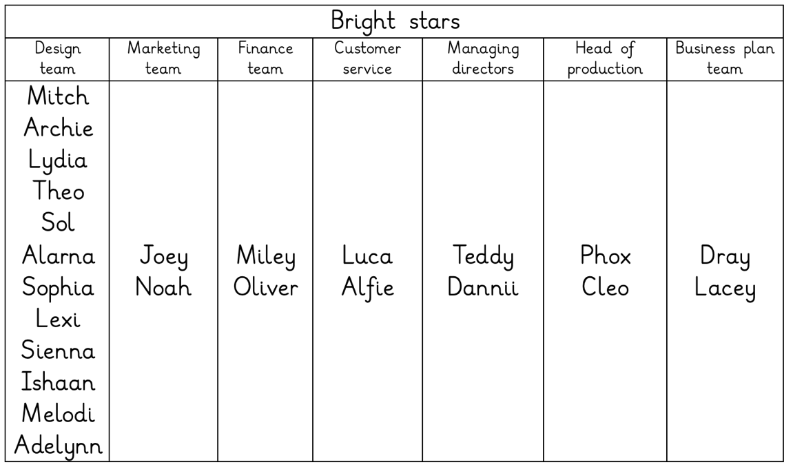

- Make a difference
What difference will your social enterprise make to your school or your local community?
Our social enterprise will make a positive difference by:
- Bringing people together – our workshops will help children and families spend time together and bond while being creative
- Encouraging creativity – we will help students learn new skills like sewing and designing
- Improving wellbeing – making crafts can help people relax and feel happy
- Building confidence – children will feel proud of creating something themselves
- Supporting our school/community – we can donate some of our profits to school projects or local charities
- Reducing waste – if we use recycled socks, we help protect the environment
What UN Global Sustainability Goals does your social enterprise best fit with?
Goal 3: Good Health and Well-being
Our workshops support mental wellbeing through creative activities and social interaction
Goal 4: Quality Education
We teach practical skills like sewing, creativity and teamwork
Goal 11: Sustainable Cities and Communities
We help build a stronger, more connected local community
Goal 12: Responsible Consumption and Production
We promote sustainability by reusing or recycling materials

