WORKSHEET:
Business Plan (once completed this is submitted as a Week 9 report)

Our BRIGHT STARS Social Enterprise Business Plan
School Name:
Gosforth C of E Primary School and Nursery

Social Enterprise Business Name:
Kindness Crew

What are you raising money for (cause/charity)?
Calderwood House

- Business Description
What is your business idea?
We will be creating Kindness Kits for residents of Calderwood House in Egremont. The kits will contain toiletries, a pocket heart and a card with a positive message.

Is it a product or a service?
We will be creating a product to donate to residents at Calderwood House in Egremont.

- Production
What do you need to be able to do it?
We will need paper bags to keep the items in. We will need to purchase the toiletries and make the cards and hearts.

- Finances
What will you do with your £50?
Think creatively. Remember you can write to organisations to ask for free donations and can reinvest at any time
What will you spend your £50 on?
We will spend the £50 on making up the first few bags so we can share with idea with parents.

What will you charge for your product or service?
We are hoping that parents will sponsor a bag at the cost of £8 each.

- Marketing
Who are your customers?
We will be holding a sale of things that we have made in school so the other pupils in school will be our customers.

How will you advertise/ raise awareness of your social enterprise?
We will use Class Dojo so the parents are aware of the sale. We will put posters up so the pupils know the sale is coming.

Where and when will you sell your product or service?
We will have the one off sale to make more money for bags in school.

Will you design a logo or have a mission statement?
We do have a logo. It was designed by Poppy.
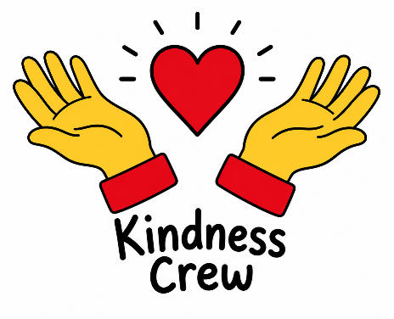
- Job roles
Who is going to do what? Who is in charge?
Our managing director is Rowan
MDs personal assistants – Sasha and Arwen
Finance – Monty and Thomas
Marketing & sales – Joe, Ember and Benjamin
Designers – Leo, April, Mathilda and Phoebe
Production – Rafi, Seth, Poppy and Evan
Quality control – Xander, Joshua and Mikey

- Make a difference
What difference will your social enterprise make to your school or your local community?
We are hoping that as a new resident of Calderwood House they would really appreciate having essential toiletries and a welcoming card. Working with Calderwood House will also raise awareness in school of the work they do in our community.

What UN Global Sustainability Goals does your social enterprise best fit with?
Good Health and Well-being because providing homeless people with Kindness Kits promotes good health and wellbeing by helping to meet both physical needs and emotional needs.

